"Inward": Lioness Film Productions Debuts Thought-Provoking Short Film Exploring Family Struggles During Pandemic
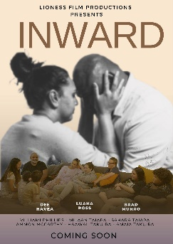
The new short film, shot on location on the Gold Coast in just two days, explores themes of suicidal ideation, body dysmorphia, online bullying, parental expectations, and the importance of families looking inward for support. “The cast includes 24-year-old Bradley Munro, an actor living with Down Syndrome, depicting his lived experience in a powerful performance that helps break down stigmas to living with disability.
Lioness Film Productions, an independent production house based on the Gold Coast, produced the film. The film delves into the lives of a large and disconnected family as they navigate their way through the aftermath of a pandemic.
"Inward" follows the sudden loss of an affluent lifestyle, forcing the family to turn inward and face their own personal struggles. "With 'Inward', our goal was to create a film that would resonate with audiences of all ages and backgrounds, by exploring themes that are relatable to many families. I am excited for the world to see this film and hope it will inspire people to be there for one another, especially during challenging times" - Lepeka Lynn, Writer/Producer of "Inward".
"We're thrilled to share this film with the world and hope it will inspire people to be there for one another, especially during difficult times," said Liana Taiapa, owner of Lioness Film Productions and the film's director and producer. "We're also excited to break down stigmas on people with disabilities and diversity of family.” Everyone has a voice and a story to tell."
The film will have a private red-carpet screening at HOTA on Saturday 4th February and will then be available on
Facebook Watch Premiere Launch of "Inward" will be held on February 6th, 2023, at 7 pm on the following pages:
https://www.facebook.com/lionessfilmproductions,
For more information, please visit Lioness Film Productions' website at www.lionessfilmproductions.com.au.

Media contact:
Company Name: Lioness Film Productions
Contact Person: Liana Taiapa
Phone: 0413756054
Email: info@lionessfilmproductions.com.au
City: Gold Coast
State: QLD, 4214
Country: Australia
Website: www.lionessfilmproductions.com.au

